

Health, Safety, Security,
and Environment (HSSE) Policy



Health, Safety, Security,
and Environment (HSSE) Policy

Effective Date: 1st JAN 2026

Contents
1. Purpose 3
2. Scope 3
3. Health and Safety 4
4. Security 4
5. Environment 4
6. Compliance 5
7. Continuous Improvement 5
8. Accountability 5

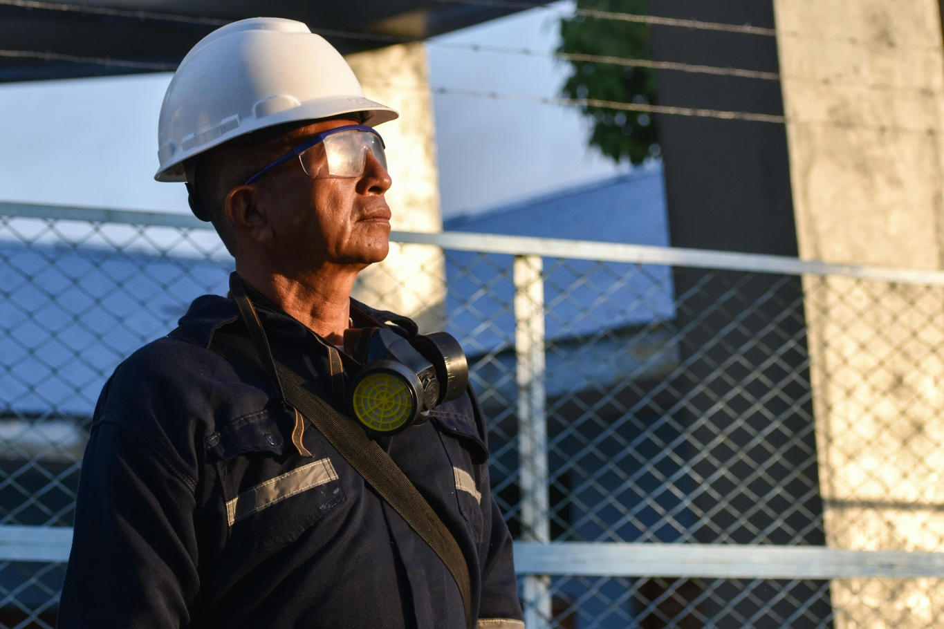

Purpose

The purpose of this policy is to ensure the health, safety, security, and environmental protection of all employees, contractors, visitors, and stakeholders involved in our company as an IT Systems Integrator Service Provider / Vendor / Operator.

Scope

This policy applies to all employees, contractors, and visitors at all our company offices and during all company-related activities.
Locations:

- Headquarter (HQ) -- 2nd Floor, Lot 12630, Block 16 KCLD, Cha Yi Goldland,
Jalan Tun Jugah, 93350 Kuching, Sarawak, Malaysia
(2) Warehouse – 42B, Lot 6778, Lorong 3A, 93350 Kuching, Sarawak, Malaysia
(3) Miri Office -- Lot 14513, 1st Floor, Airport Commercial Centre, Jalan Airport,
98000 Miri, Sarawak, Malaysia.

Health and Safety

• Commitment: N-Base is committed to providing a safe and healthy work environment.
• Ergonomics: Workstations will be designed to promote good posture and reduce the risk of repetitive strain injuries.
• Mental Health: Support programs will be available to address stress and mental health concerns.
• Emergency Procedures: Clear procedures will be established for responding to health and safety emergencies, including fire drills and first aid training.
• Incident Reporting: All incidents, no matter how minor, must be reported immediately to a supervisor.

Security
• Cybersecurity: Robust measures will be implemented to protect against cyber threats, including regular software updates (especially Anti-Virus software and Windows updates), firewalls, and employee training on phishing and other cyber risks.
• Access Control: Only authorized personnel are allowed access to company premises and sensitive data.
• Data Protection: Measures will be taken to protect sensitive information from unauthorized access, including encryption and secure storage solutions.
• Incident Response: A clear incident response plan will be in place to address any security breaches promptly.

Environment
• Sustainability: N-Base is committed to minimizing its environmental impact through sustainable practices.
• E-Waste Management: Proper disposal and recycling of electronic waste will be enforced.
• Energy Efficiency: Efficient use of energy will be promoted, including the use of energy-saving devices and practices.
• Resource Use: Efficient use of resources such as water and paper will be encouraged.

Compliance

• Regulations: N-Base will comply with all relevant health, safety, security, and environmental laws and regulations.
• Audits: Annual in-house audits will be conducted to ensure compliance with this policy.

Continuous Improvement
• Feedback: Employees are encouraged to provide feedback on HSSE practices.
• Review: This policy will be reviewed annually and updated as necessary to reflect
changes in regulations and company operations.

Accountability

• Management: Management is responsible for implementing and enforcing this
policy.

• Employees: All employees are expected to adhere to this policy and contribute to
a safe and secure work environment.

